**Que 1) Plot a histogram,**

10, 13, 18, 22, 27, 32, 38, 40, 45, 51, 56, 57, 88, 90, 92, 94, 99

**Solution:**

**Histogram from given data:**

Let, X= {10,13,18,22,27,32,38,40,45,51,56,57,88,90,92,94,99}

Curve for given data:

We get bell curve in histogram in red line also called as Frequency polygon.

**Que 2) In a quant test of the CAT Exam, the population standard deviation is known to be 100. A sample of 25 tests taken has a mean of 520. Construct an 80% CI about the mean.**

**To construct an 80% Confidence Interval (CI) about the mean,**

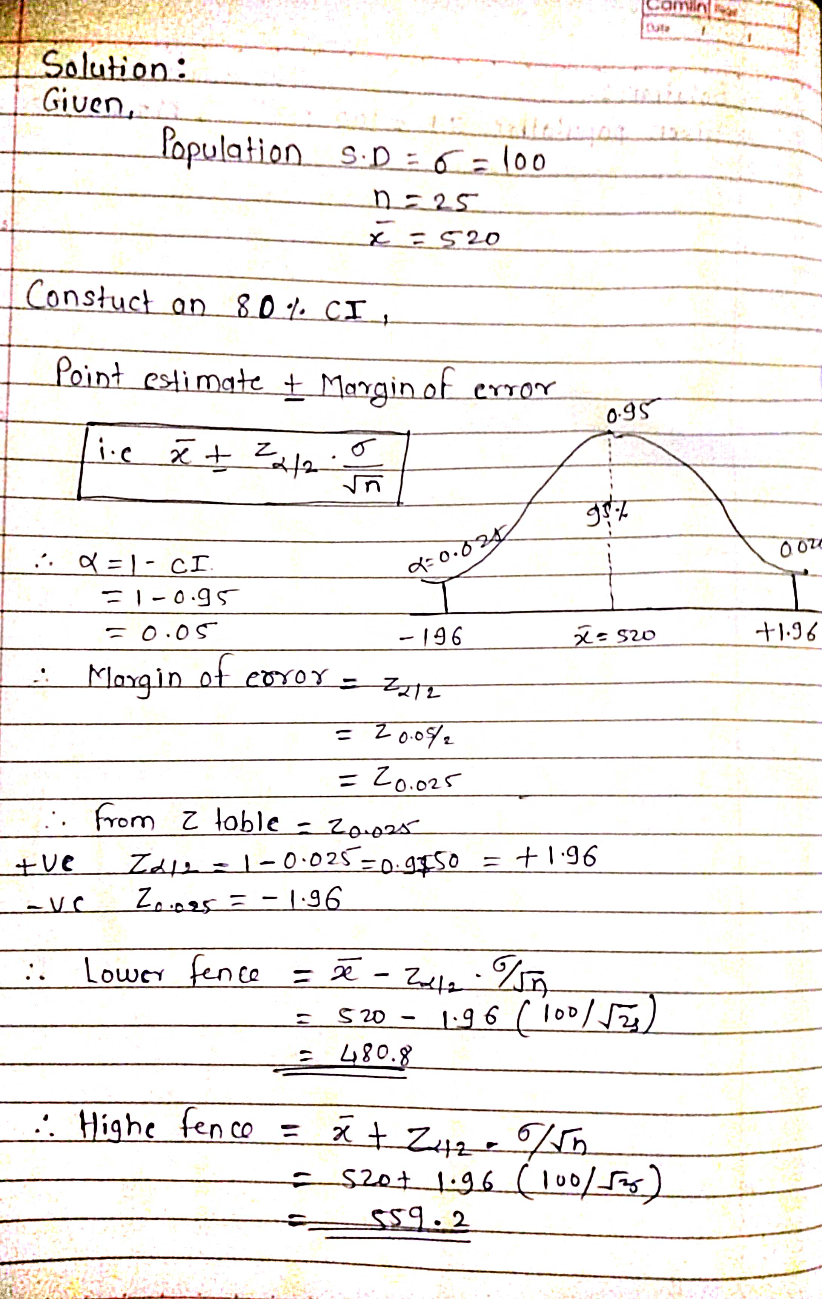

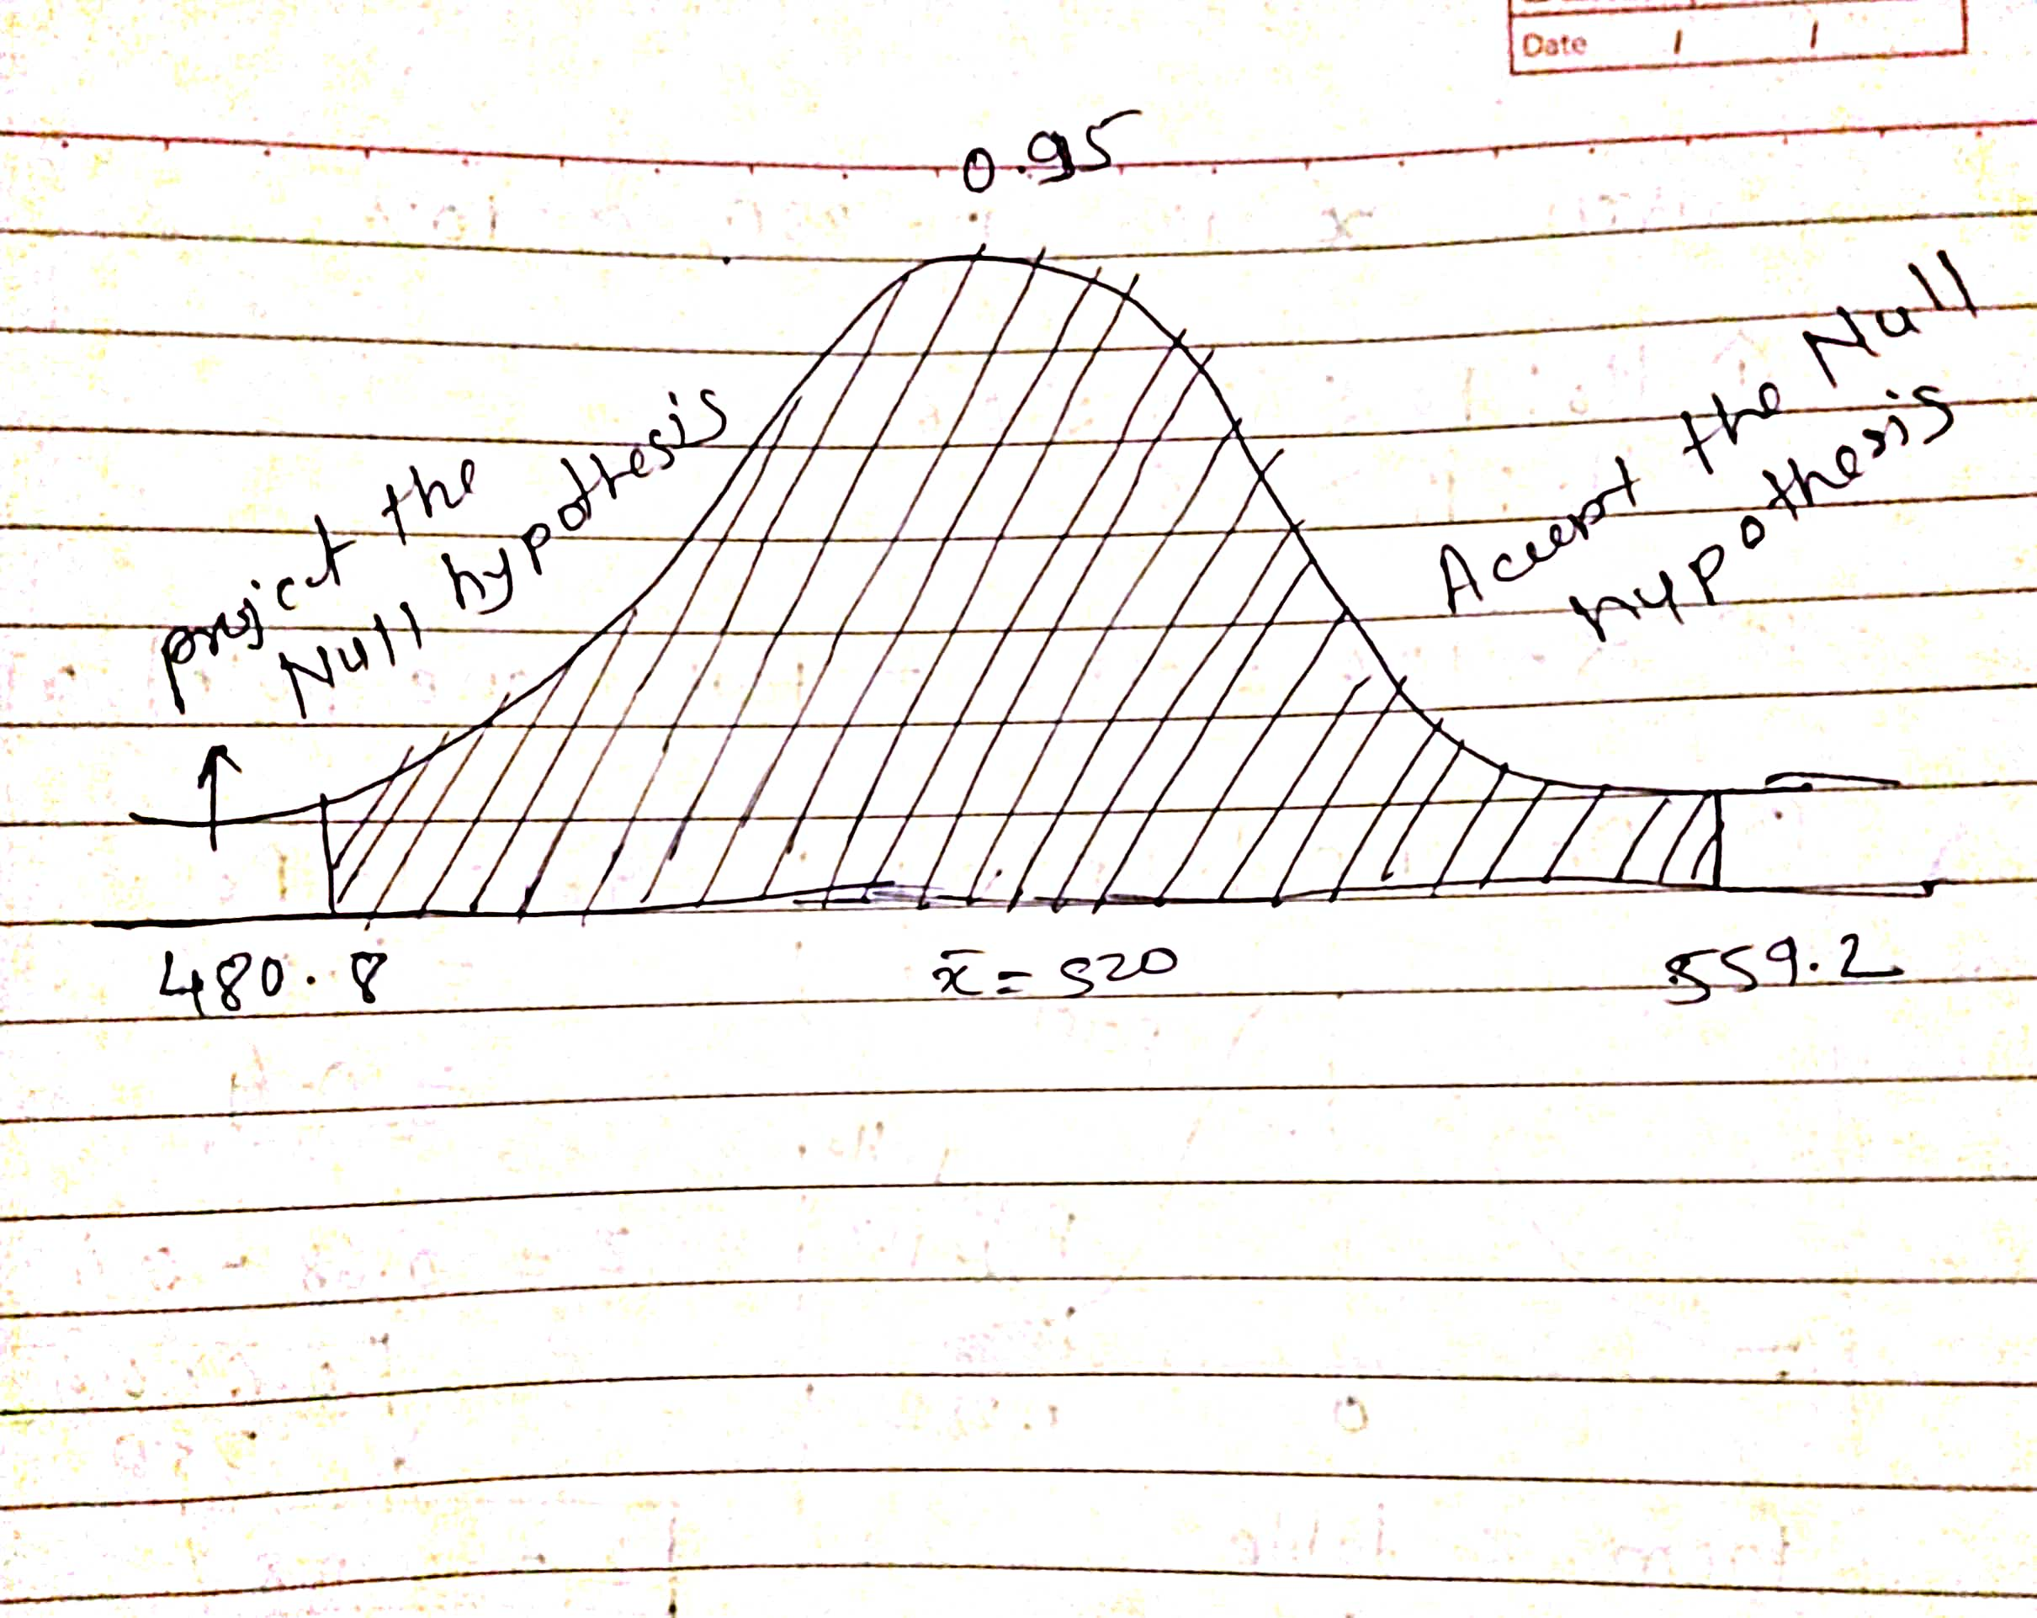

**Que 3) A car believes that the percentage of citizens in city ABC that owns a vehicle is 60% or less. A sales manager disagrees with this. He conducted a hypothesis testing surveying 250 residents & found that 170 residents responded yes to owning a vehicle.**

1. **State the null & alternate hypothesis.**
2. **At a 10% significance level, is there enough evidence to support the idea that vehicle owner in ABC city is 60% or less.**

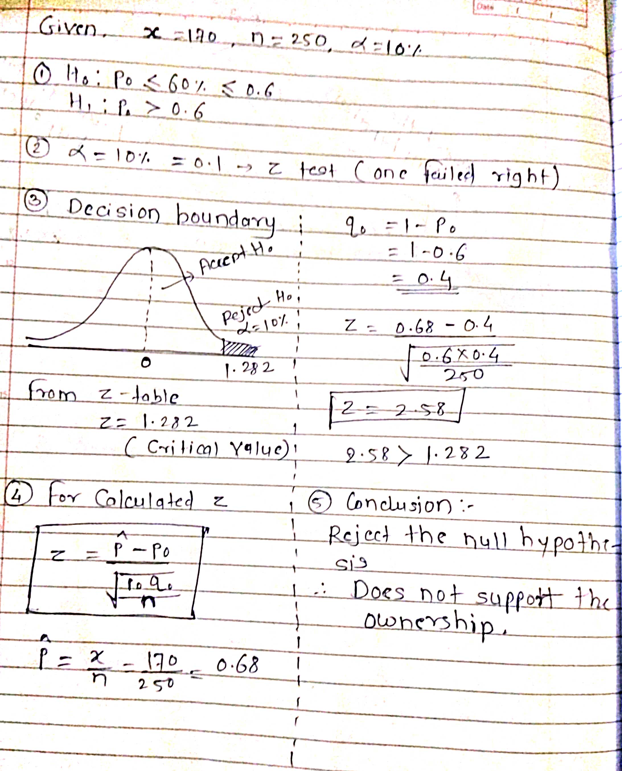

**Que 4) What is the value of the 99 percentile?**

**2,2,3,4,5,5,5,6,7,8,8,8,8,8,9,9,10,11,11,12**

The 99 percentile is the value that is greater than or equal to 99% of the values in the given dataset. To find the 99th percentile in the provided dataset, we need to first arrange the numbers in ascending order: 2,2,3,4,5,5,5,6,7,8,8,8,8,8,9,9,10,11,11,12.

Next, we need to calculate the rank of the 99th percentile, which can be calculated as 99/100 x n, where n is the total number of values in the dataset.

In this case, n = 20,

so the rank of the 99th percentile is (99 x 20)/100 = 19.8,

which we can round up to 20

Finally, we can find the 99th percentile value by locating the value at the rank of 20. In this dataset, the value at the 20th rank is 12.

Therefore, the 99th percentile value is 12.

**Que 5) In left & right-skewed data, what is the relationship between mean, median & mode?**

**Draw the graph to represent the same.**

**Solution:**

In left-skewed data, the mean is typically less than the median and mode. In right-skewed data, the mean is typically greater than the median and mode. This is because the mean is influenced by extreme values, while the median and mode are resistant to outliers. In general, the relationship between mean, median, and mode depends on the shape of the distribution of the data

Comparing Positive, symmetrical and left skewed frequency distribution over mean, median and mode. (Empirical Relationship)

1. **Symmetrical Frequency Curve**

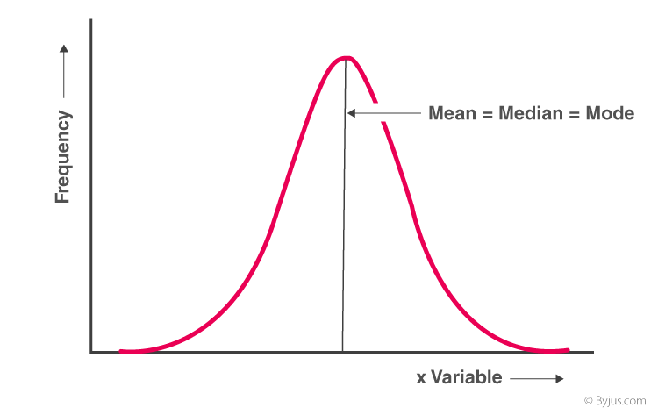

**Mean = median = mode**

1. **Positively Skewed Frequency Distribution**

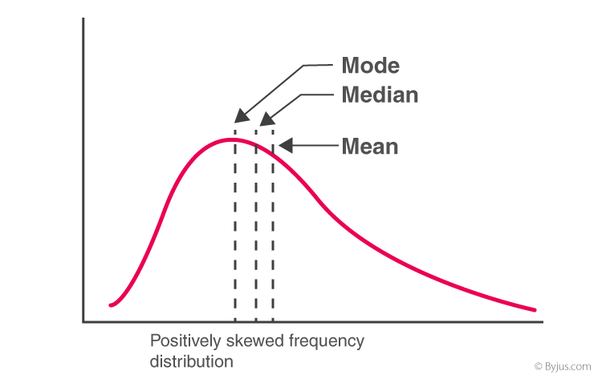

**Mean > median > mode**

1. **Negatively Skewed Frequency Distribution**

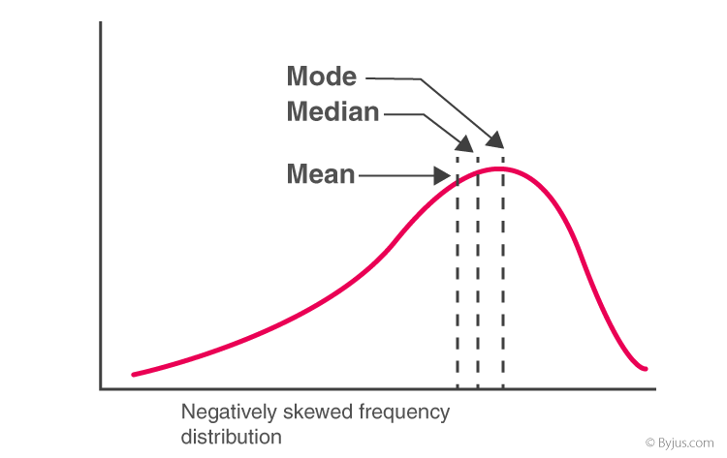

**Mode > median > mean**